Chapter 19, Problem 50.

Derive the s-domain expression for the t parameters of the circuit in Fig. 19.104.

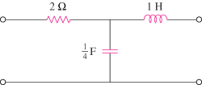

Figure 19.104
For Prob. 19.50.

